The Street,  Chirton,  Devizes,  Wiltshire,  SN10 3QS  Phone: 07910195330  Email: Chirtonpips@hotmail.co.uk |  |  | Forest School  Chirton Pips Pre-school

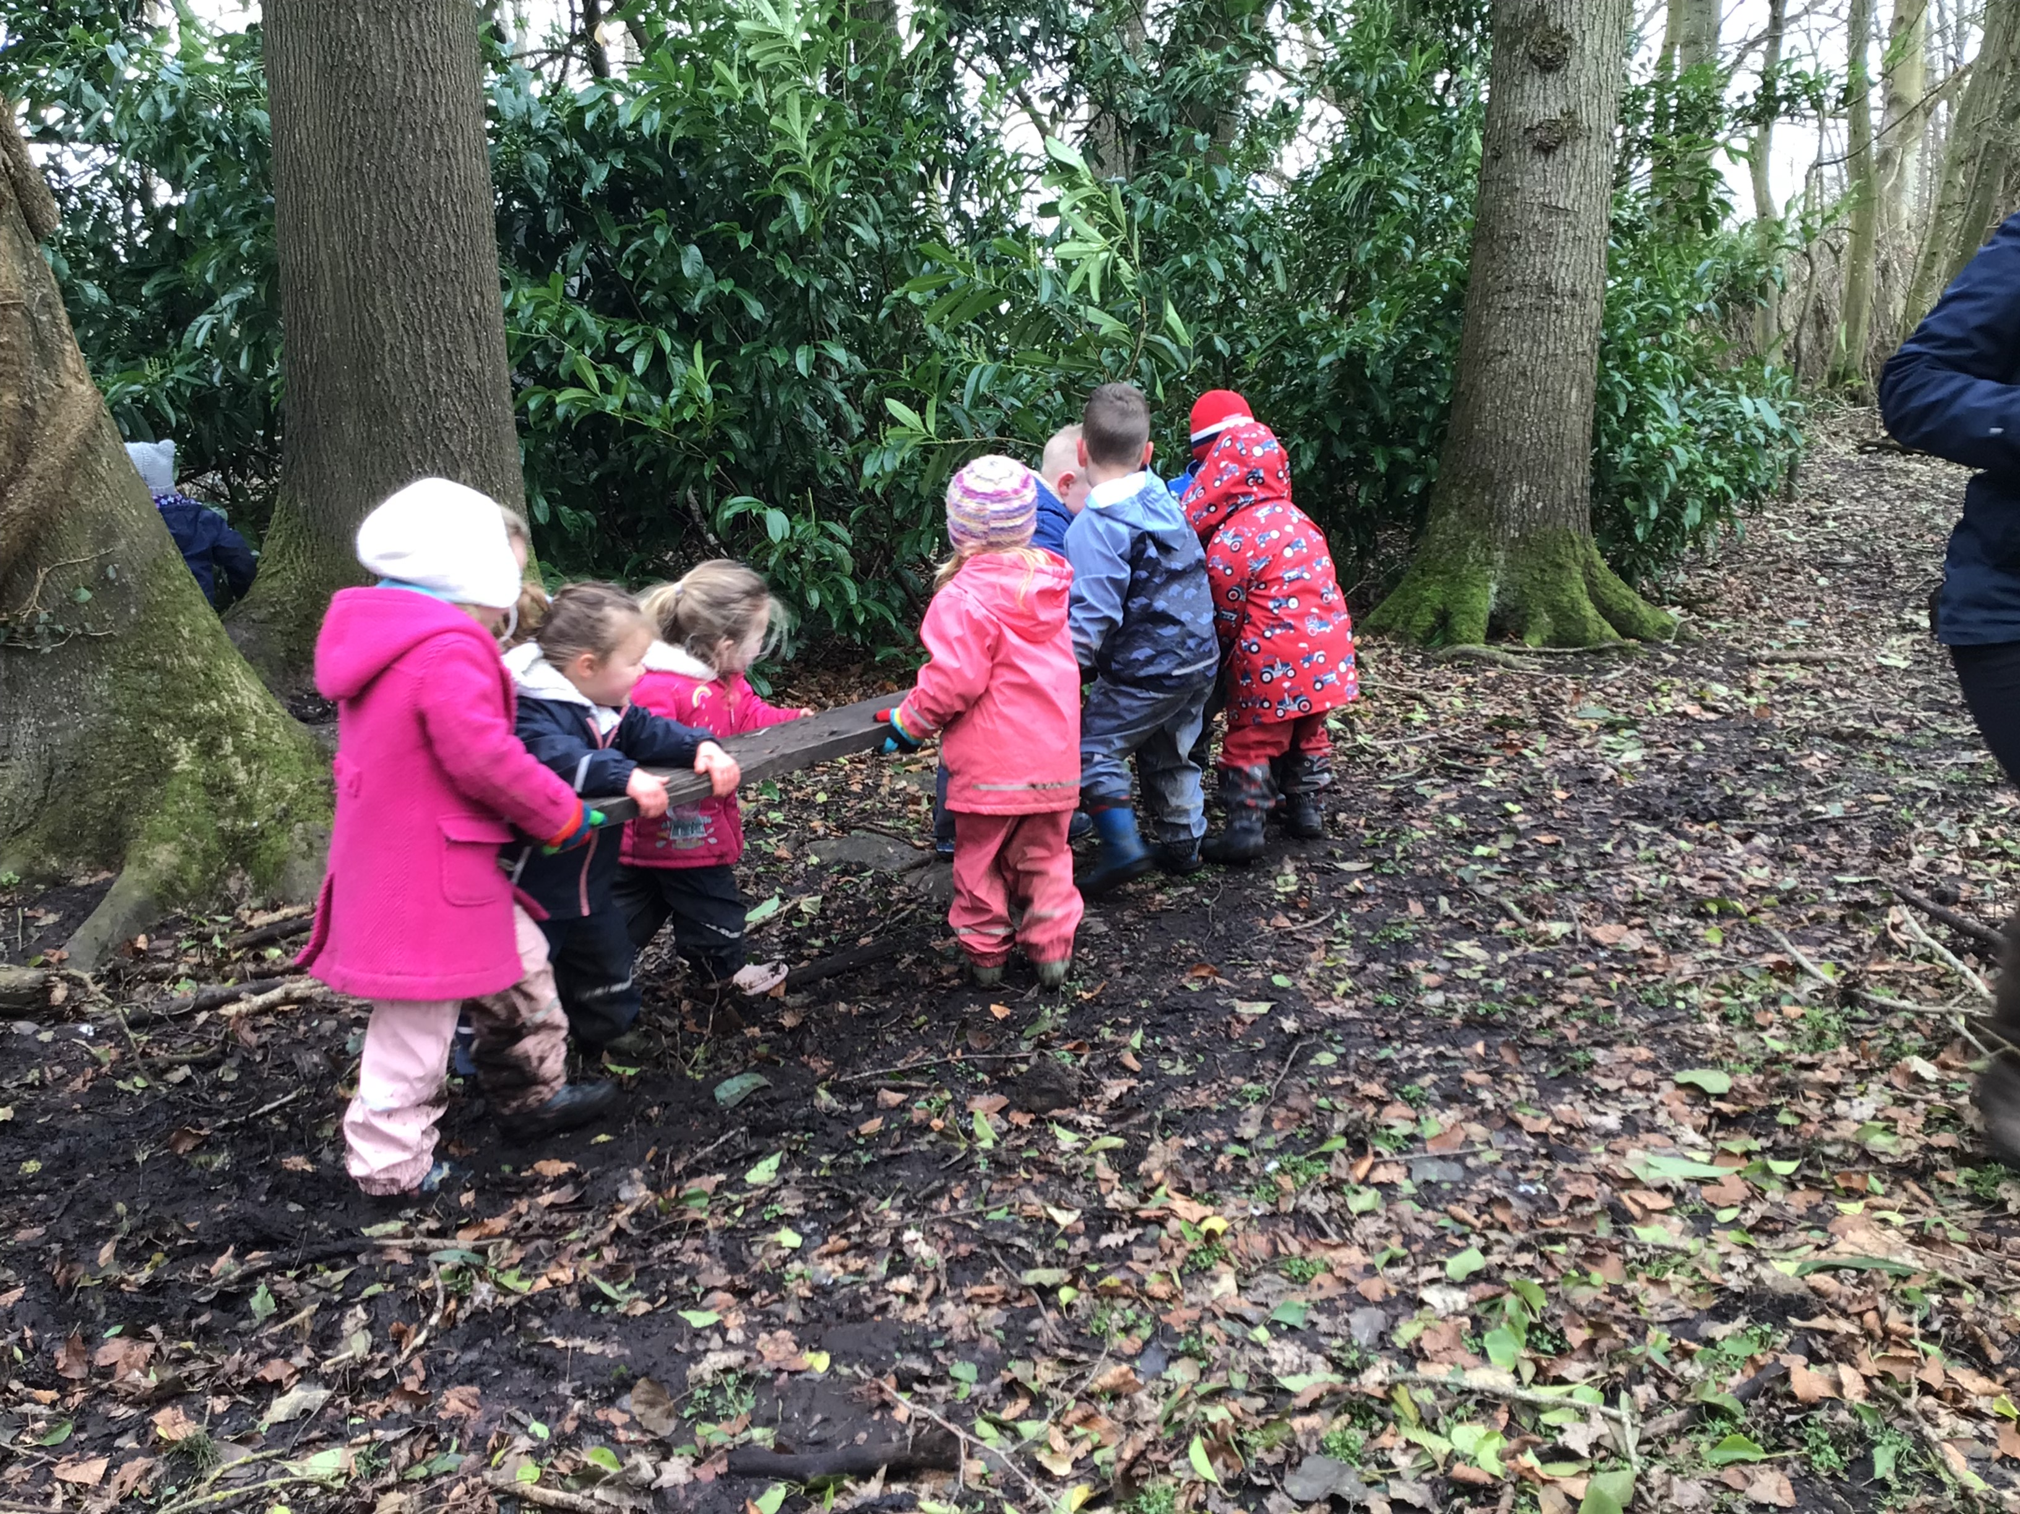  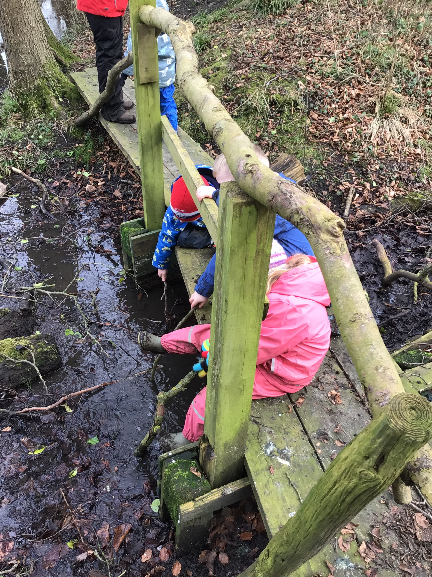Web sites to visit  Tick bite risks and prevention of Lyme disease: resources - GOV.UK (www.gov.uk)  Resources and activities hub | Forestry England  https://www.chirtonschool.co.uk |  |  | Routine  At the start of the session, we talk through the Rules of the Forest School, with the children telling us why we do /don’t do things and we discuss the boundaries.  - We have our snack. In the winter this is around the fire and the children can cook their S’mores with the Forest School leaders if they wish too. We have hot chocolate, water, or milk. Fires are only lite in the winter months due to the ground being peat based. we use this time to read a story while the children.  - The children then have free flow, we have an adult led activities if they wish or we follow their interests of that day. This could be retelling stories, den building, bug hunt, hide and seek or finding a Gruffalo, and climbing trees with an adult.  - Lunch time with the opportunity for the children to reflect on what they have done and enjoyed/learnt.  - Back to Pips for 1 0’ clock.  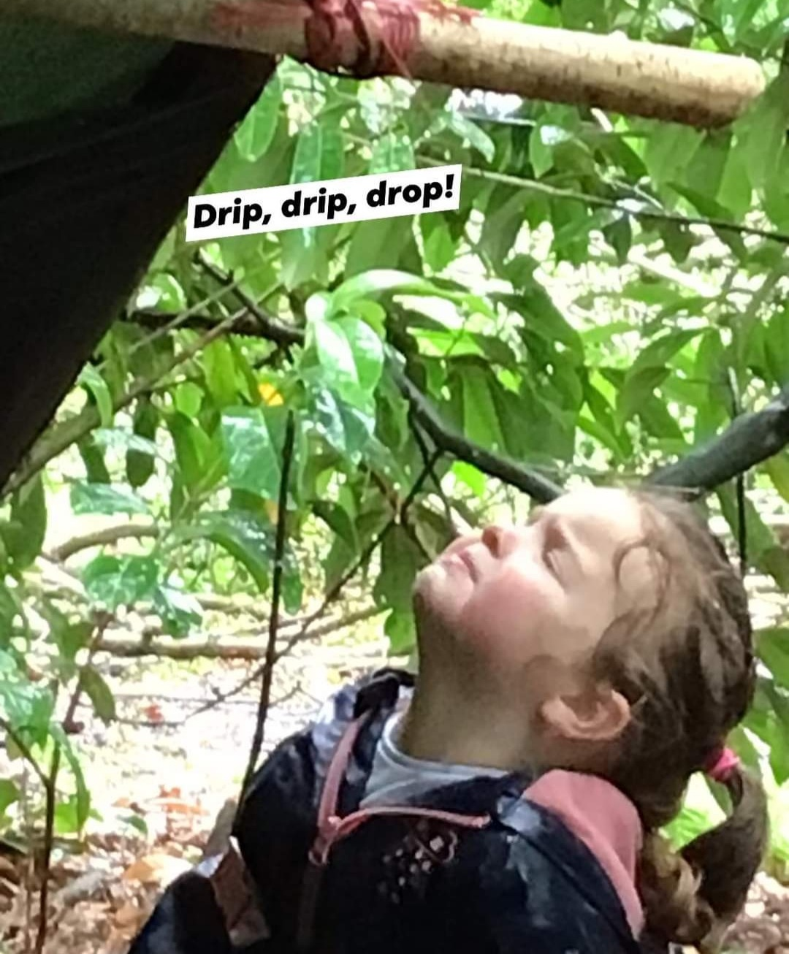

Our Sessions  Our Forest School sessions run on a Monday morning and a Friday morning. We leave preschool at 9:15 and return at 1pm having lunch in the woods, unless it is too cold then we will come back early.  Forest School continues throughout the year. The only weather we do not go out in is thunder or strong winds above 25miles per hour. If children are getting too cold then we will return early, but this is a decision for the Forest School Leaders. 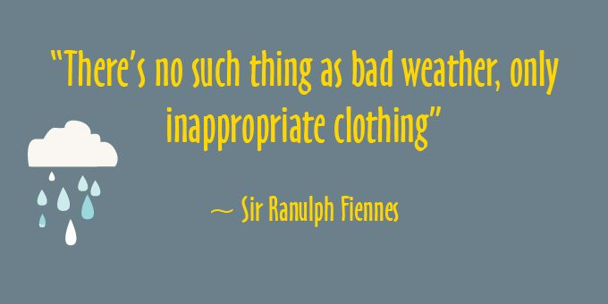  What to wear  It is essential that children have their legs and arms covered throughout the year. We have deer that use the woods and would like the children to be protected from Ticks. See gov.uk/ticks for more information.  In the spring and early Autumn please wear long sleeves t-shirts, long trousers, waterproof coat, trousers, and wellie boots. It may be chilly enough to wear a vest and or fleece.  In the summer, if hot we suggest long trousers and long sleeve t-shirts with a fleece or waterproof coat. The woods can be very chilly even in hot weather due to the tree canopy. If the children do get hot, they can take a layer off as long as all arms and legs are still covered, best to go prepared.  The winter months we ask you layer your child up. Thermal base layers, long sleeves t-shirts, trousers and fleeces or thick jumper with waterproof coat and trousers and two or three pairs of socks with boots.  We ask that children bring gloves throughout the year not only to keep warm but in case we want to investigate plants that may irritate their skin.  Warm hats or sun hats depending on the weather. |  |  | Forest School  Forest School aims to connect children with nature, giving children the opportunity to learn about meteorological seasons, environmental sounds, weather, different types of flora and faunas.  Forest school was developed in the UK in the 1990’s as an approach to early years learning, initially inspired by play-based, nature-centered pedagogy of Scandinavia. The Forest School Association, an independent body representing Forest School in the UK has provided the following:  ‘Forest School is an inspirational process that offers all learners regular opportunities to achieve and develop confidence and self-esteem through hands on learning experiences in a woodland or natural environment with trees.’  Forest School has an ethos of therapeutic educational learning that aims to maximize social, emotional, mental health and developmental potential by allowing children to manage their own risks, have more independence in guiding their own learning, achieve goals, be active, play and learn through direct experience with nature.  Children are curious and have a strong desire to play and explore the world around them. Forest School gives them opportunity to make their own choices which helps to drive their own learning and development. Free play gives children space and independence and a chance to imagine and learn social skills, whilst adults guided activities help children learn new skills.

Examples of activities we do in the woods |  | Play Time supporting  Climbing trees and balancing on the see saw  Story Telling and listening to stories  Measuring branches, and the depth of the stream  Personal, Social, and Emotional, Math’s, Communication and Language, Knowledge of the world, Physical skills, Literacy and Expressive arts and design development.  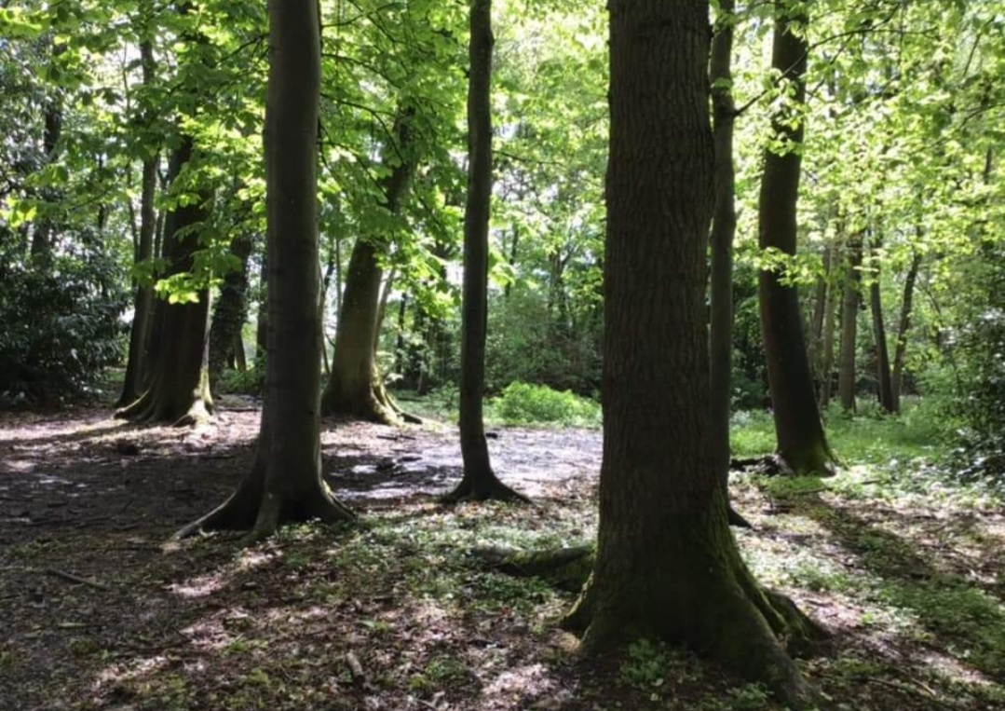  Listening to environmental sounds  Hide and seek games  Den building  Bug and Fungus hunting

